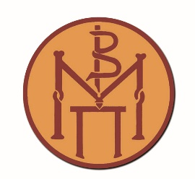

Press Release
Collaboration between the Museum of Byzantine Culture and the Deputy Mayoralty for Municipal Communities and Neighborhoods and Care for the Elderly of the Municipality of Thessaloniki
Thessaloniki, 13 November 2025

On Tuesday, 11 November 2025, an educational activity was held at the White Tower, in collaboration with the 12th and 5th Open Care Centers for the Elderly (KAPI) of the Municipality of Thessaloniki.
During the event, participants toured the exhibition of the White Tower, listened to stories about the city of Thessaloniki, and explored the history of the Tower and the city walls through archival photographs.
Participants shared personal memories connected with the White Tower—recalling their first dates and describing what the surrounding area used to look like. They also recounted stories about the “Garden of the White Tower,” known as the “largest entertainment center in the East,” which operated from 1907 to 1956. We learned that the Kalouta sisters performed there as children, as did Zozó Sapountzaki and other prominent actors and singers of the era.
The activity at the White Tower is the fourth in a series organized within the framework of the memorandum of cooperation signed in June 2024 between the Museum of Byzantine Culture and the Deputy Mayoralty for Municipal Communities and Neighborhoods and Care for the Elderly of the Municipality of Thessaloniki.
The event was coordinated by Ms. A. Kolyza from the Municipality of Thessaloniki and Mr. A. Antonaras and Ms. E. Fourliga from the Museum of Byzantine Culture.
.

