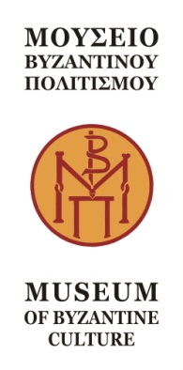
Thessaloniki, 3 September 2025

PRESS RELEASE

We would like to inform you that the new pricing policy of the Museum of Byzantine Culture is the following:
the full ticket price for visiting the permanent exhibition of the Museum of Byzantine Culture, without distinction between summer and winter seasons, remains at 8 euros, while from April 1, 2026 it will rise to 10 euros. For visiting the White Tower, the full ticket price remains at 6 euros, without distinction between summer and winter seasons, while from April 1, 2026 it will rise to 8 euros.
A reduced ticket price of 50% is set for the Museum of Byzantine Culture and the White Tower for:
a. Greek citizens and citizens of other European Union member states over 65 years of age, upon presentation of their police ID card or passport to confirm age and country of origin.
b. Accompanying parents for educational visits of primary schools of European Union member states and of the European Economic Area.
c. Accompanying teachers for educational visits of primary, secondary and tertiary schools and institutions from countries outside the European Union.
An exemption from the entrance fee is also established for a number of categories of visitors (23).
In addition, on the following dates, admission is free for everyone:
- March 6th (Melina Mercouri Memorial Day)
- April 18th (International Monuments Day)
- May 18th (International Museum Day)
- Last weekend of September (European Days of Cultural Heritage)
- October 28th (National Holiday)
For more details visit our website www.mbr.gr

